Wireshark Lab 1: IP

Group Details:

Mark:

 | Question | Answer
1 | Select the first ICMP Echo Request message sent by your computer, and expand the Internet Protocol part of the packet in the packet details window.  What is the IP address of your computer? | 100.64.198.150  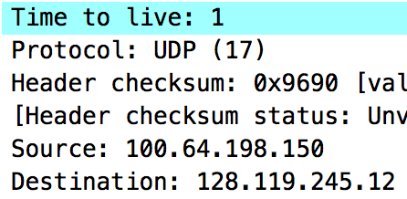
2 | Within the IP packet header, what is the value in the upper layer protocol field? | UDP (17)  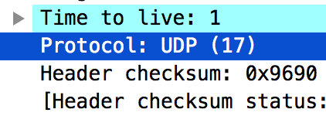
3 | How many bytes are in the IP header? How many bytes are in the payload of the IP datagram? Explain how you determined the number of payload bytes. | 20  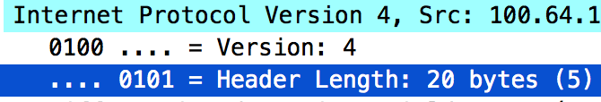
4 | Has this IP datagram been fragmented? Explain how you determined whether or not the datagram has been fragmented. | This datagram has not been fragmented.  We apply “ip.fragment” filter in Wireshark, and this packet did not go through the filter. This is probably because its size is smaller than MTU in datalink layer.
5 | Which fields in the IP datagram always change from one datagram to the next  within this series of ICMP messages sent by your computer? | The “Identification” field increments by one each time.
6 | Which fields stay constant? Which of the fields must stay constant? Which fields must change? Why? | IP of source and destination, version number, protocol must stay constant. For packets sent by traceroute, they have the same value.  Identification and checksum have to change every time. Identification number is used to distinguish different packets.
7 | Describe the pattern you see in the values in the Identification field of the IP datagram | Identification increments by one every time.
8 | What is the value in the Identification field and the TTL field? | Identification: 0x5060 (20576)  TTL: 64  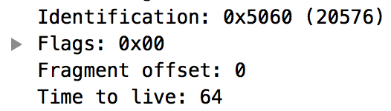
9 | Do these values remain unchanged for all of the ICMP TTL-exceeded replies sent to your computer by the nearest (first hop) router? Why? | Identification increments by one every time, but TTL remains 64. It recommended to set TTL to 64 so that the return message can be delivered.
10 | Find the first ICMP Echo Request message that was sent by your computer after you changed the Packet Size in pingplotter to be 2000. Has that message been fragmented across more than one IP datagram? | Yes. The UDP packet was fragmented into two IP packets.  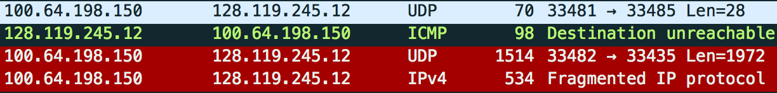
11 | Print out the first fragment of the fragmented IP datagram. What information in the IP header indicates that the datagram been fragmented? What information in the IP header indicates whether this is the first fragment versus a latter fragment?  How long is this IP datagram? | The “more fragments” of this packet is set.  The fragment offset is 0.  The length is 1500.  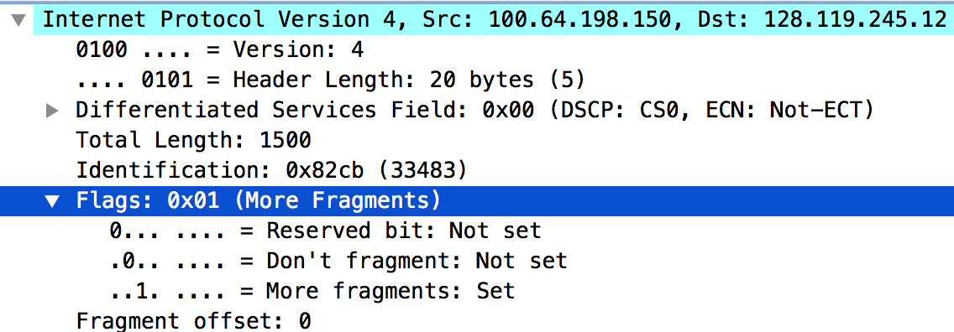
12 | Print out the second fragment of the fragmented IP datagram. What information in the IP header indicates that this is not the first datagram fragment? Are the more  fragments? How can you tell? | The fragment offset is not zero.  There are no more fragments. The “more fragments” flag is not set.  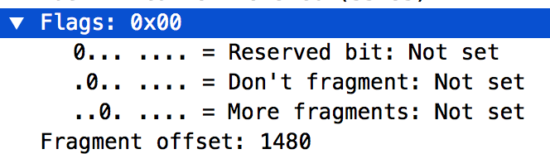
13 | What fields change in the IP header between the first and second fragment? | The “more fragments” flag.  Fragment offset.  Checksum.  Total length.
14 | How many fragments were created from the original datagram? | 3.
15 | What fields change in the IP header among the fragments? | Fragment offset and checksum always change.  Total length and more fragments flag changed between the 2nd and 3rd packet.

